Setting Operator-Name in Clearpass
The Operator-Name attribute is used to identify the Visited Site to the Home Site. i.e. when a user joins at a Visited Site the name of the site is passed through in a RADIUS Request to the Home Site. The Home Site might use this information to generate statistics on where its users are visiting or to report problems with the Visited Site.
Setting the Operator-Name in Clearpass is impossible if your configuration uses a \\RADIUS Proxy
Service to proxy unknown requests to the Jisc NRPS but easy if you use the \\RADIUS Enforcement (Generic)
Service with the NRPS as Authentication Sources.
Below the configuration assumes the use a \\RADIUS Enforcement (Generic)
Service because that's the only way that Clearpass will allow attributes to be added to the Access Request.

Authentication Source
The assumption is that there is a Service which has Jisc's NRPS as the authentication sources:
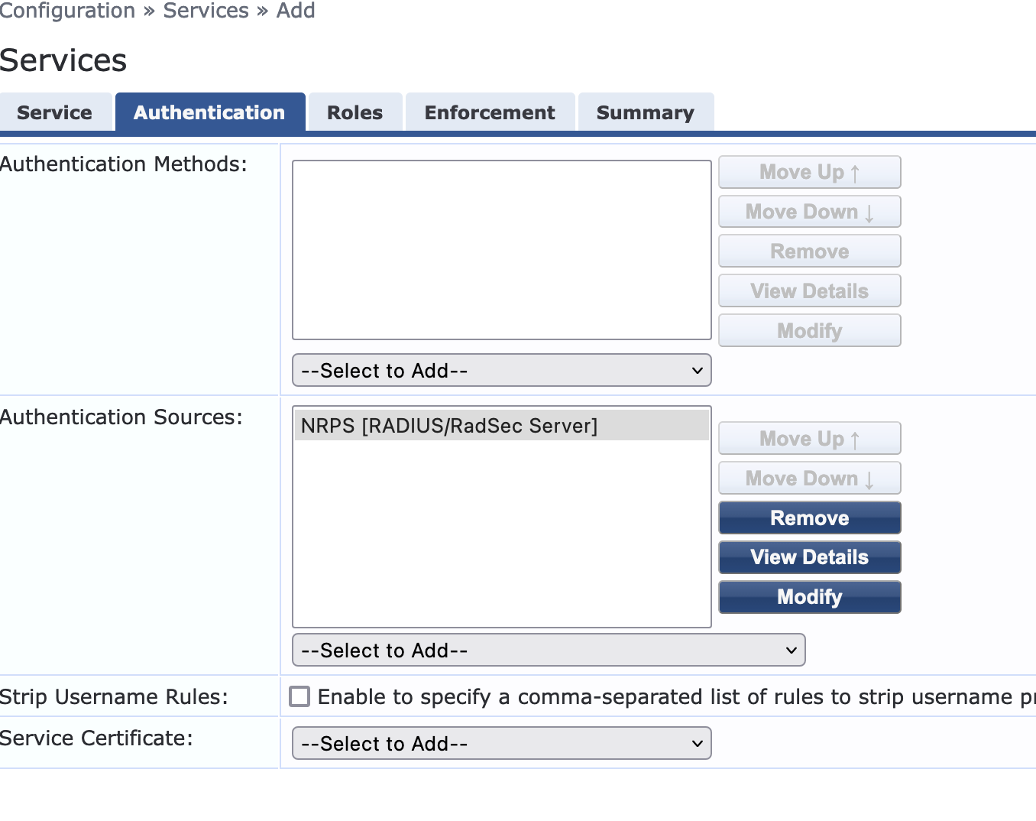IMAGE
Then the Source (or Sources) need to be configured to add the Operator-Name Attribute:
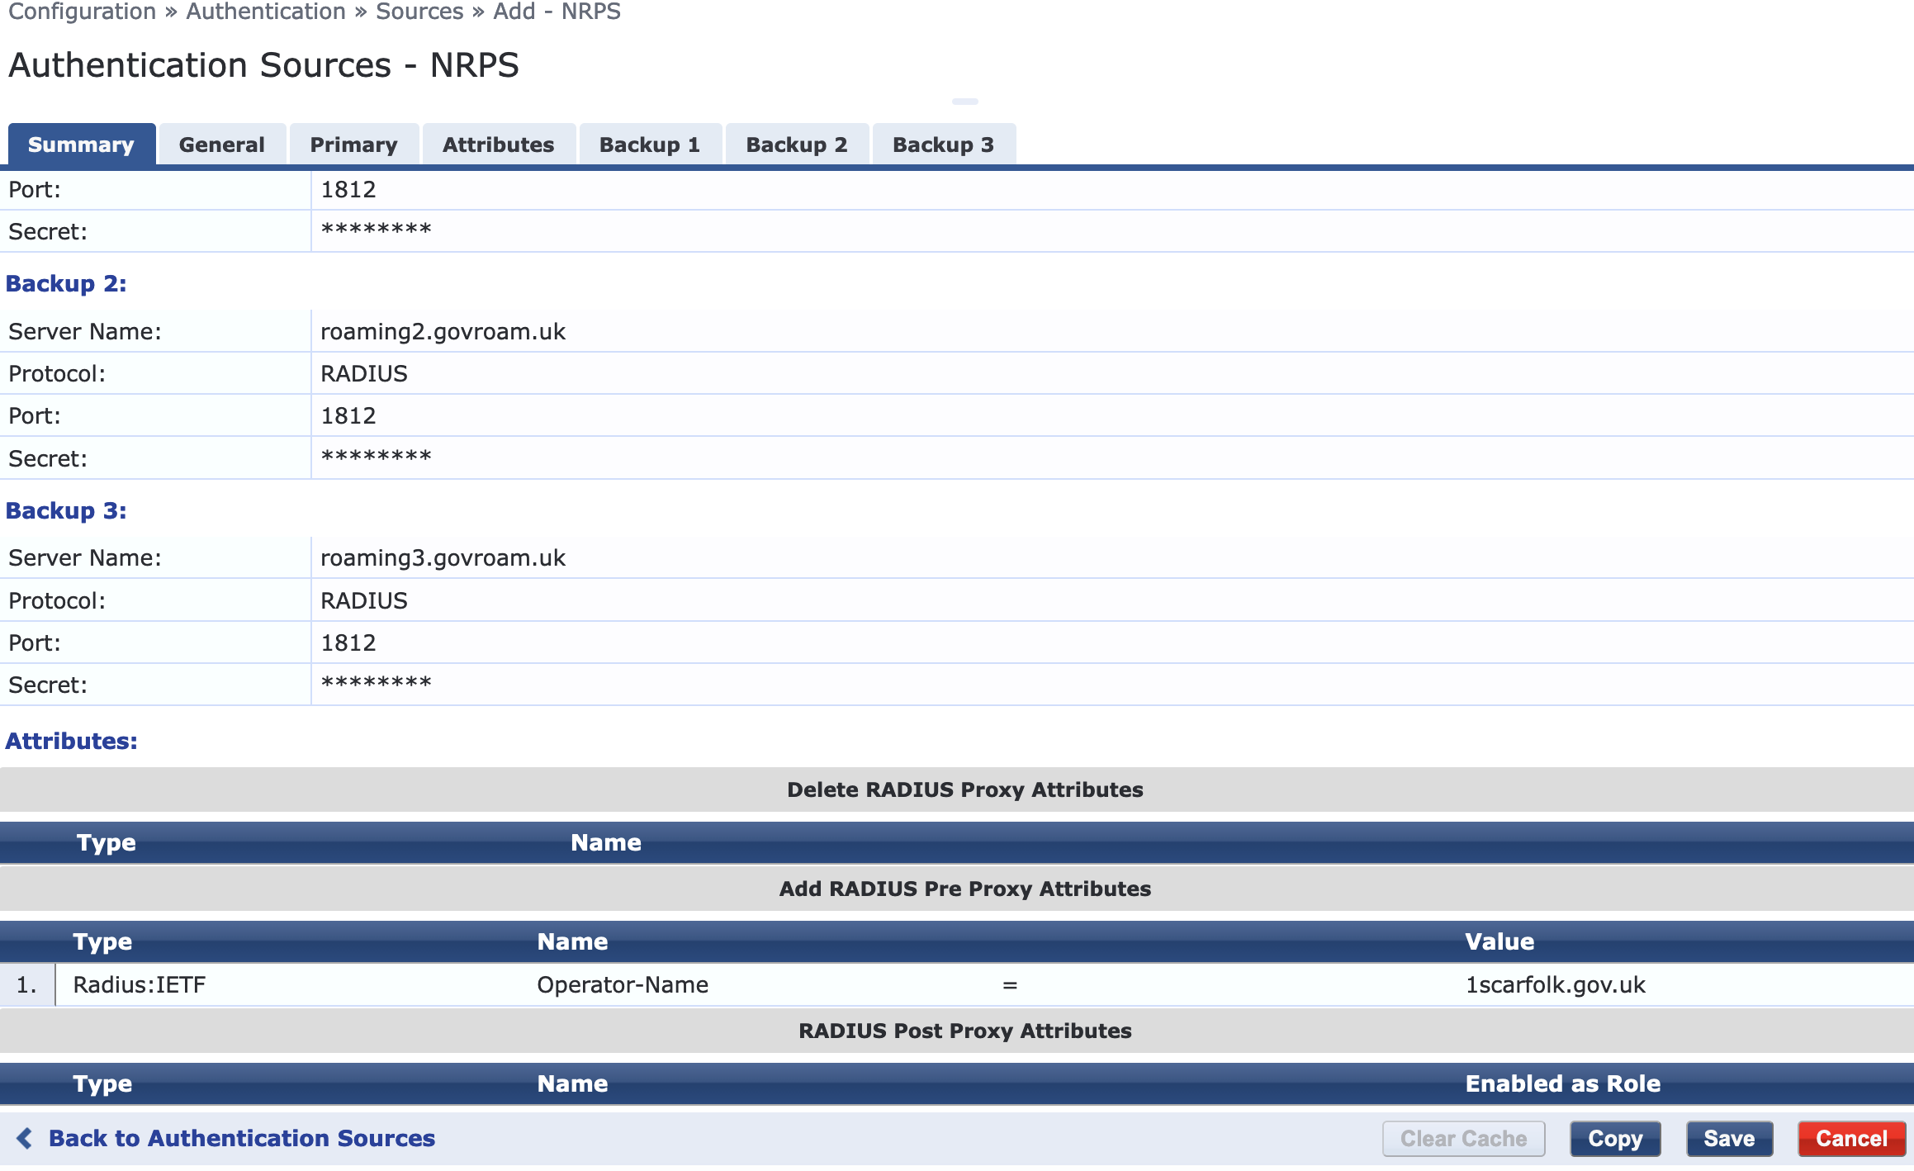IMAGE
with the identifier for your site. Please use your realm, the primary if you have more than one. The format is 1<realm>. The '1' just means that there's a string to follow. So, if your realm is holby,nhs,uk then your Operator-Name value would be 1holby.nhs.uk

